DML workshop 24/03/25

Questions on training and testing a Neural Network
You should be able to answer these questions. They also address common errors on the main task. Do not use ChatGPT, as this is an exercise in using notebooks and googling around to find basic descriptions. Knowing what terminology to use and how to phrase it is an important skill, and you can develop this by searching online yourself.
- What is the difference between parameters and hyperparameters?
- Briefly describe/explain these hyperparameters
  - Learning rate
  - Epoch
  - Input/Output dimension
  - Number of K-folds
  - Activation function
  - Batch size
  - Iteration (In the context of neural network training)
- What does a batch size of 1 and 10 mean?
- For N training samples, what equation roughly estimates the number of iterations?
What is wrong with the following code blocks? How might we fix them?
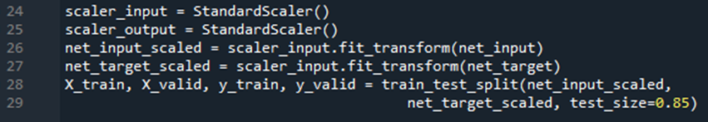
- These Lines have 2 or more errors
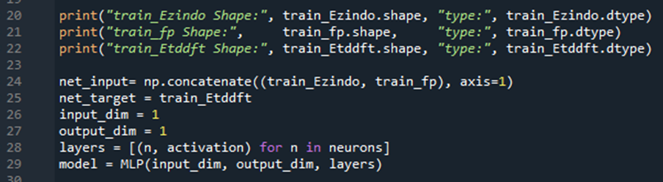
- These lines will cause one error.
This is Console output before the error is thrown:
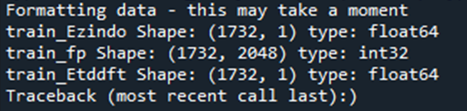
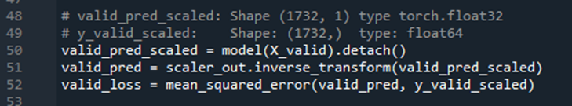
- There are three things wrong, but only one will throw an error. What are they? (The comments show the correct information of the two variables)
- What does .reshape(-1,1) do to numpy arrays?
(i.e. net_target = train_Etddft.reshape(-1,1))
Why/what might we need to use it for in the context of this workshop?

